PROGRAM NO.-9

**AIM** –.Using the concept of polymorphism. Write a program to calculate the area & perimeter of

different kind of shapes ( points , circles , rectangles ,squares ,line).

SOURCE CODE

#include<iostream>

#include<math.h>

using namespace std;

class shape

{

protected:

int x;

int y;

int x1;

int y1;

public :

virtual void input()=0;

virtual void calculate()=0;

};

class point :public shape

{

public :

void input()

{

cout<<"\n\t\t POINT ";

cout<<"\nENTER THE CO-ORDINATES OF POINT :";

cin>>x>>y;

}

void calculate()

{

cout<<"\n\t\t POINT " ;

cout<<"\nAREA : 0";

cout<<"\nPERIMETER : 0";

}

};

class line :public shape

{

public :

void input()

{

cout<<"\n\t\t LINE " ;

cout<<"\nENTER THE TWO (x,y) CO-ORDINATES OF LINE :";

cin>>x>>y;

cout<<"\nENTER THE TWO (x1,y1) CO-ORDINATES OF LINE :";

cin>>x1>>y1;

}

void calculate()

{

cout<<"\n\t\t LINE ";

cout<<"\nAREA : 0";

float p = sqrt ( pow(x-x1,2)+pow(y-y1,2));

cout<<"\nPERIMETER : "<<p;

}

};

class circle :public shape

{

public :

void input()

{

cout<<"\n\t\t CIRCLE " ;

cout<<"\nENTER THE CO-ORDINATES OF CENTER OF CIRCLE :";

cin>>x>>y;

cout<<"\nENTER THE CO-ORDINATES OF ANY POINT ON CIRCUMFERENCE OF CIRCLE :";

cin>>x1>>y1;

}

void calculate()

{

cout<<"\n\t\t CIRCLE ";

float r = sqrt ( pow(x-x1,2)+pow(y-y1,2));

cout<<"\nAREA :"<<3.14*r*r;

cout<<"\nPERIMETER : "<<2*3.14*r;

}

};

class rectangle :public shape

{

public :

void input()

{

cout<<"\n\t\t RECTANGLE " ;

cout<<"\nENTER THE CO-ORDINATES OF CORNER OF RECTANGLE :";

cin>>x>>y;

cout<<"\nENTER THE CO-ORDINATES OF DAIGONALLY OPPOSITE CORNER :";

cin>>x1>>y1;

}

void calculate()

{

cout<<"\n\t\t RECTANGLE ";

float area = (x-x1)*(y-y1);

float perimeter =fabs( 2*(x-x1)+2*(y-y1) );

cout<<"\nAREA :"<<area;

cout<<"\nPERIMETER : "<<perimeter;

}

};

class square :public shape

{

public :

void input()

{

cout<<"\n\t\t SQUARE " ;

cout<<"\nENTER THE CO-ORDINATES OF CORNER OF SQUARE :";

cin>>x>>y;

cout<<"\nENTER THE CO-ORDINATES OF DAIGONALLY OPPOSITE CORNER OF SQUARE :";

cin>>x1>>y1;

}

void calculate()

{

cout<<"\n\t\t SQUARE ";

float area = (x-x1)*(y-y1);

float perimeter = fabs( 2*(x-x1)+2*(y-y1) );

cout<<"\nAREA :"<<area;

cout<<"\nPERIMETER : "<<perimeter;

}

};

int main()

{

shape *s[5];

point p;

line l;

circle c;

rectangle r;

square sq;

s[0]=&p;

s[1]=&l;

s[2]=&c;

s[3]=&r;

s[4]=&sq;

for(int i=0; i<5; i++)

{

s[i]->input();

}

for(int i=0; i<5; i++)

{

s[i]->calculate();

}

return 0;

}

OUTPUT

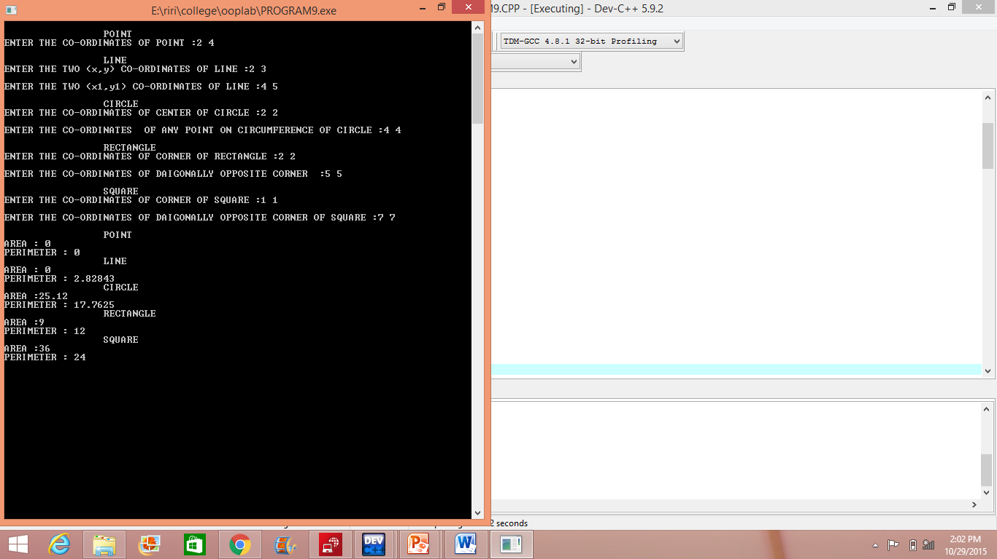

PROGRAM NO.-10

**AIM** –. Write a program using virtual function . Base class , derived classes and their member data are

illustrated below :-

SOURCE CODE

#include<iostream>

using namespace std;

class Company

{

string name;

public:

virtual void getdata()

{

cout<<"Enter Company Name : ";

cin>>name;

}

virtual void display()

{

cout<<"Company Name : "<<name<<"\n";

}

};

class Desktop : public Company

{

string modelName;

float price;

public:

void getdata()

{

cout<<"Enter Model Name : ";

cin>>modelName;

cout<<"Enter Price : ";

cin>>price;

}

void display()

{

cout<<"Model Name : "<<modelName<<"\n";

cout<<"Price : "<<price<<"\n";

}

};

class Laptop : public Company

{

string modelName;

float price;

public:

void getdata()

{

cout<<"Enter Model Name : ";

cin>>modelName;

cout<<"Enter Price : ";

cin>>price;

}

void display()

{

cout<<"Model Name : "<<modelName<<"\n";

cout<<"Price : "<<price<<"\n";

}

};

int main()

{

Company* cptr;

Company c1;

Desktop d1;

Laptop l1;

cptr = &c1;

cptr->getdata();

cptr = &d1;

cptr->getdata();

cptr = &l1;

cptr->getdata();

cptr = &c1;

cptr->display();

cptr = &d1;

cptr->display();

cptr = &l1;

cptr->display();

return 0;

}

OUTPUT

